**Fun Done Planner**

* Description:

The idea for this app is for it to be an app that the user utilizes to keep track of all the tasks they have to carry out. The tasks can be categorized as either routine or special, the difference being that special tasks occur only once, and will be automatically deleted once the expiration date passes, while routine tasks will be kept in the tracker. Each special task will be given a date category of either this week, this month, or this day. When adding a task, the user will declare it as either a special or a routine task. If the task is special, the user will insert the task name, a period time and the priority level of this task. If the task is routine, the user will insert the task name, task priority, expiration date, and how often the task will be listed (daily, Weekly, Monthly). If it is a weekly task, the user will be able to assign it a day of the week. However, If the task is a monthly task, the user could choose how would be reminded. There are two ways. The first way is choosing a specific date, for example, the first of each month, the application will remind the user to pay the rent of the house. On the other hand, the user could choose a specific day of the specific week. For example, the first Friday of each month, grocery shopping task will appear on the routine task list. If the user has a routine task is done every two weeks, it will be a monthly task under the specific day category. Additionally, once a task is completed, the user will be able to go in and mark it as complete.

When using the app, the user will open it up to a screen displaying all the tasks that have yet to be completed or expired. The user will be able to press the (+) button at the bottom of the home screen to add a new task. This will pop up a window to choose whether the task they wish to add is special or routine. This choice will take them to another new screen based on which one they chose. From there, they add the rest of the information about the task. When they submit the new task, they will be taken back to the main page. There are three tabs on the top of the screen. The user will be able to edit tasks, delete tasks, or view tasks through the first tap which is all tasks tap. The second tab is the uncompleted tasks list of the current month. At the end of the day, the uncompleted routine tasks and the daily special tasks will be moved to be under this tap. Once the month has passed, all uncompleted task will be deleted. The third tab is the login information of the user. The user could change the password of the account through this tap.

* Scenes:
  + Scene 1:

The first scene is the home screen. It displays the list of the task. The user could move through the Tab Bar Controller which include all task tap, uncompleted task tap, and user profile tap. Moreover, the user could check the completed task. Finally, the user could add a new task by clicking on the (+) button on the bottom. Once the button clicked, a window will pop up to choose the type of the task.

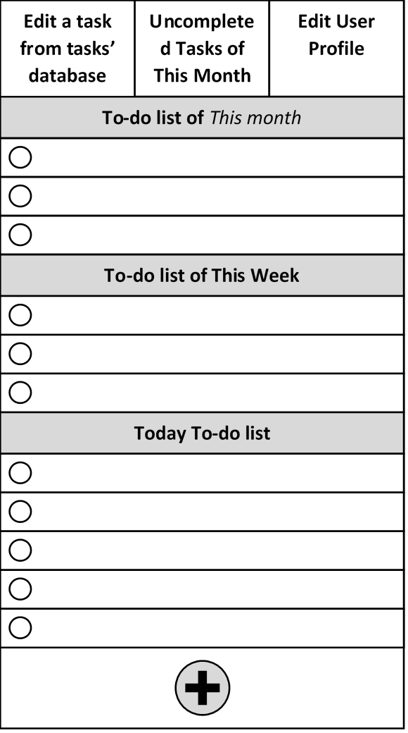 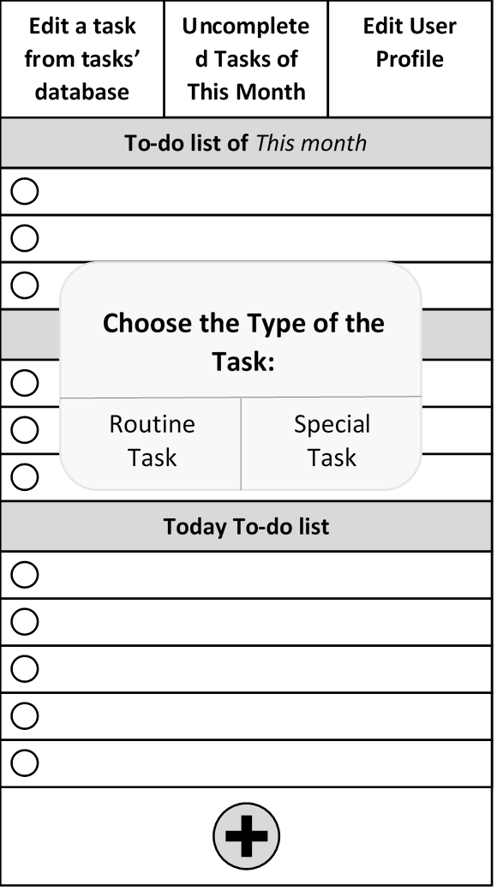

* + Scene 2:

The second scene is adding a task screen. Once the user chooses the type of the task, the adding task scene will display. The user should implement all required inputs, and press the submit button to add the new task. However, the user could press the cancel button if the user is not interested in the task.

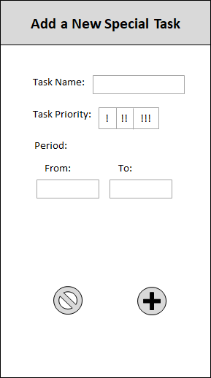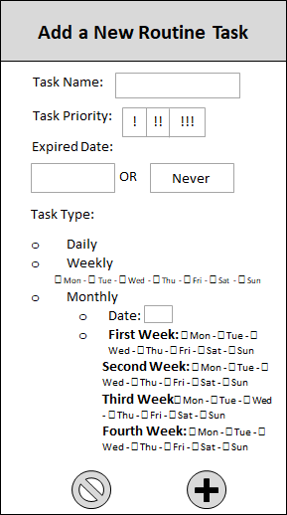

* + Scene 3:

The third scene is all task tap. This screen is viewing the database of all tasks. Through this tap, the user could view, edit or delete a task. If the user swaps the task field to the left side, two buttons will appear. One button for editing (blue button) while the second button is for deleting the task (red button).

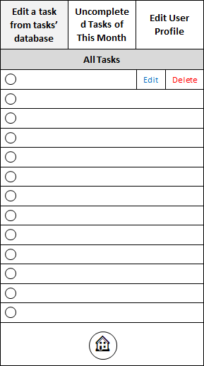

* + Scene 4:

The fourth scene is the user profile tap. Through this tap, the user could change the password of the user account. Also, the user could view which email is used and which name is chosen when the account is created.

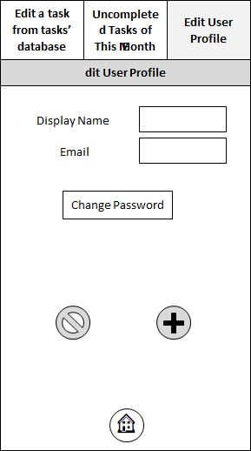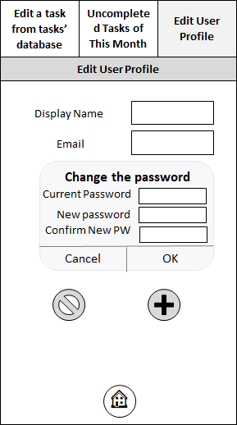

* + Scene 5:

The fifth scene is the archive tab. This tab displays uncompleted tasks of the current month. Once the new day is started and there is some uncompleted task on the home screen, it automatically will be moved to this tab. If the user finished a task late, it could be checked through this tab.

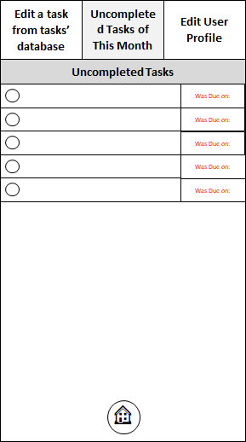

* User Controls:
  + The first user control we plan to implement is a table view on the first scene which is the home screen. Also, the table view will be used in the all tasks tab and uncompleted task tab.
  + The second user control we plan to implement are sets of radio buttons on the second scene. These radio buttons allow the user to specify both the priority of the task. Also, radio buttons will be used in adding a routine task scene to specify under which category the task will take place on.
  + The last user control we plan to implement is text boxes on both scene two and scene four. The user will use different text boxes to input the name of their task (in scene two) and change the password of their account (in scene four).